this api is host in heroku: <https://afternoon-cliffs-28090.herokuapp.com/>

I use mvc architectural pattern to build this simple demo website.

how to use each of my endpoints: **post** /register , **post** /login , **get** /profile , **get** /database , **get** /logout ,**get** /login, **get** /register

Post <https://afternoon-cliffs-28090.herokuapp.com/register>

parameters: username password

there are two examples below: one register successfully, another one fail to register since user already exist in database

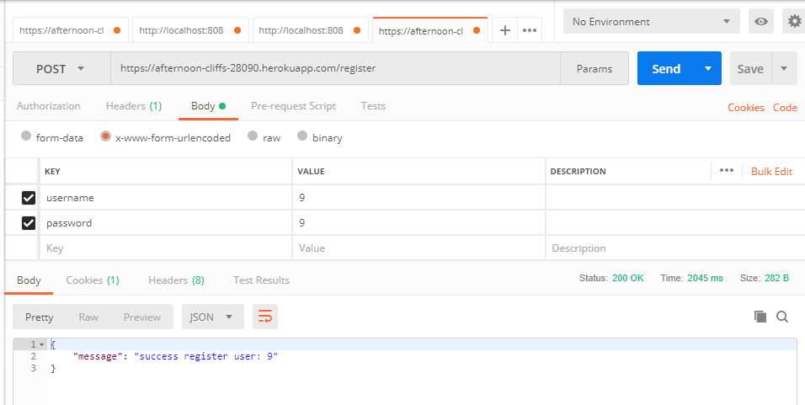

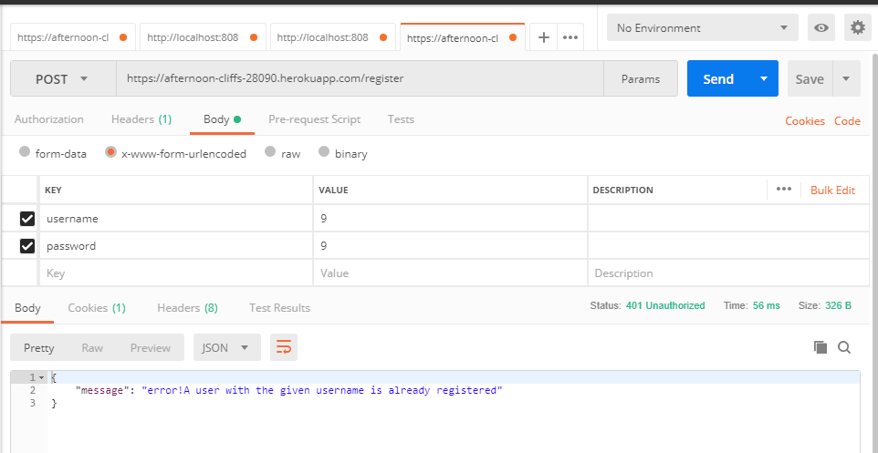

Post <https://afternoon-cliffs-28090.herokuapp.com/login>

parameters: username password

there are two examples below: one shows login successfully, another one fail to login since username or password is wrong

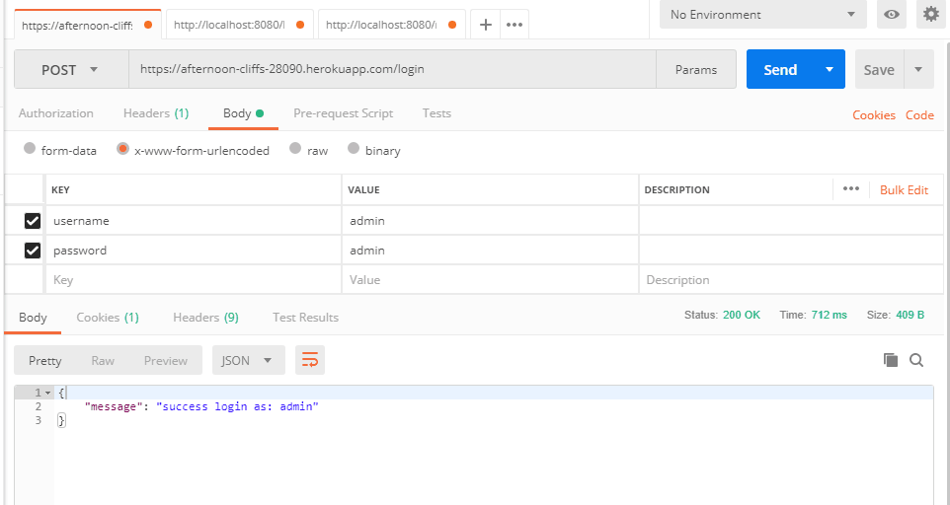

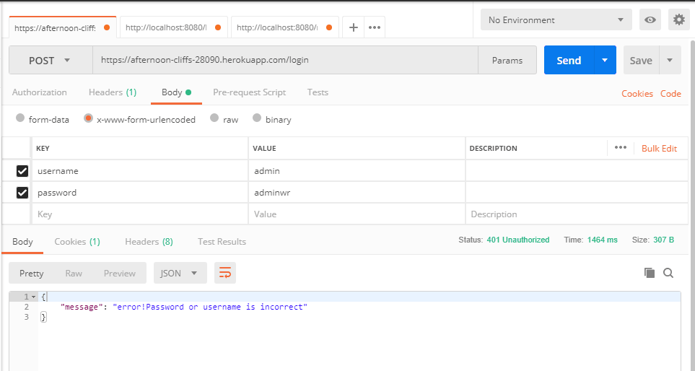

Get <https://afternoon-cliffs-28090.herokuapp.com/database>

This is /database endpoint can view all the username in database, however this endpoint is protected by isAdmin middleware, this endpoint only works for user who login as administrator, this account is special as administrator. **Username: admin Password: admin**

there are two examples below: one shows login as administrator to access this endpoint successfully, another one log in as normal user, and then fail to access this endpoint

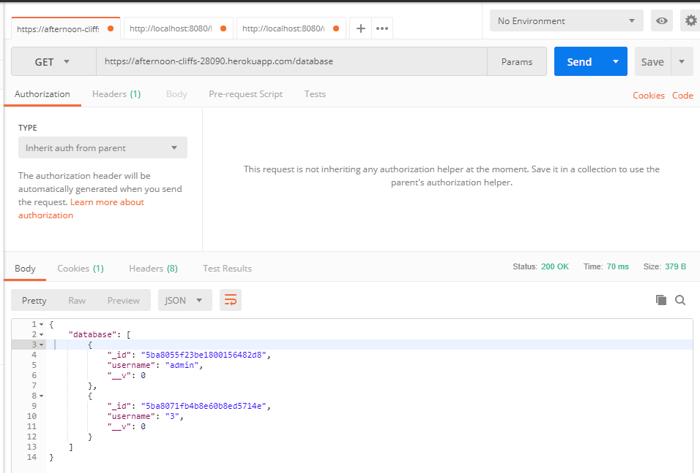

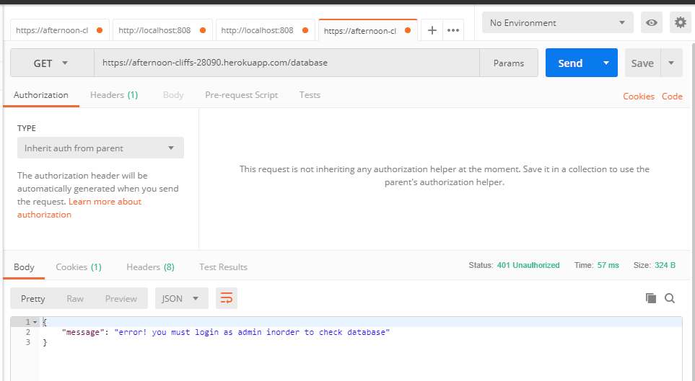

Get <https://afternoon-cliffs-28090.herokuapp.com/profile>

This is /profile endpoint can view user’s profile; however this endpoint is protected by isLogin middleware, this endpoint only works for user who login successfully.

there are two examples below: one shows access this endpoint successfully after login, another one shows fail to access this endpoint since user is not login.

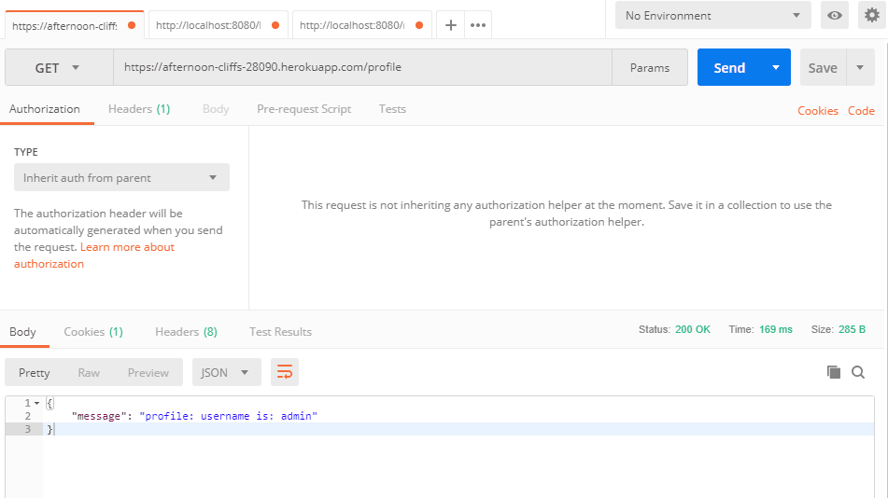

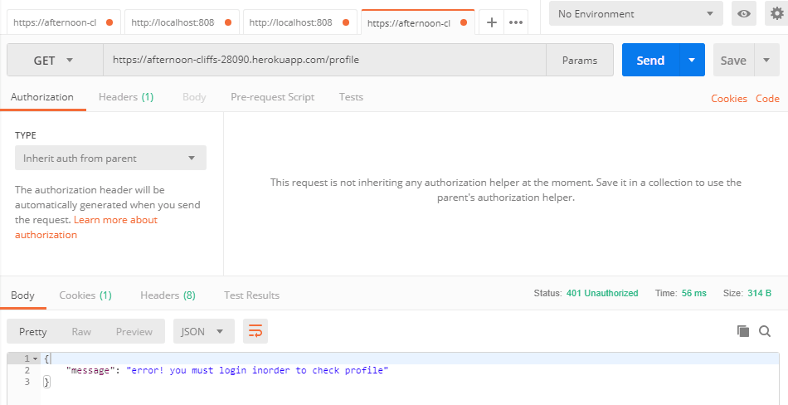

**get** <https://afternoon-cliffs-28090.herokuapp.com/logout>

this can logout user and then redirect to home page

**get** <https://afternoon-cliffs-28090.herokuapp.com/login>

this get login can show user the login form

**get** [**https://afternoon-cliffs-28090.herokuapp.com/register**](https://afternoon-cliffs-28090.herokuapp.com/register)

this get /register can show user the register form